**DAY 2 PROGRAMS**

1. Generate a program for Pascal triangle.

Estimate the time complexity for the row=5

Program :

#include<stdio.h>

int main()

{

int rows, coef = 1, space, i, j;

int count=0;

printf("Enter the number of rows: ");

scanf("%d", &rows);

for (i = 0; i<rows; i++)

{

count++;

for (space = 1; space <= rows - i; space++)

printf(" ");

count++;

for (j = 0; j <= i; j++)

{

count++;

if(j == 0 || i == 0){

coef = 1;

count++;

}

else

{

coef = coef * (i - j + 1) / j;

}

count++;

printf("%4d", coef);

}

printf("\n");

count++;

}

printf("%d",count);

return 0;

}

OUTPUT:

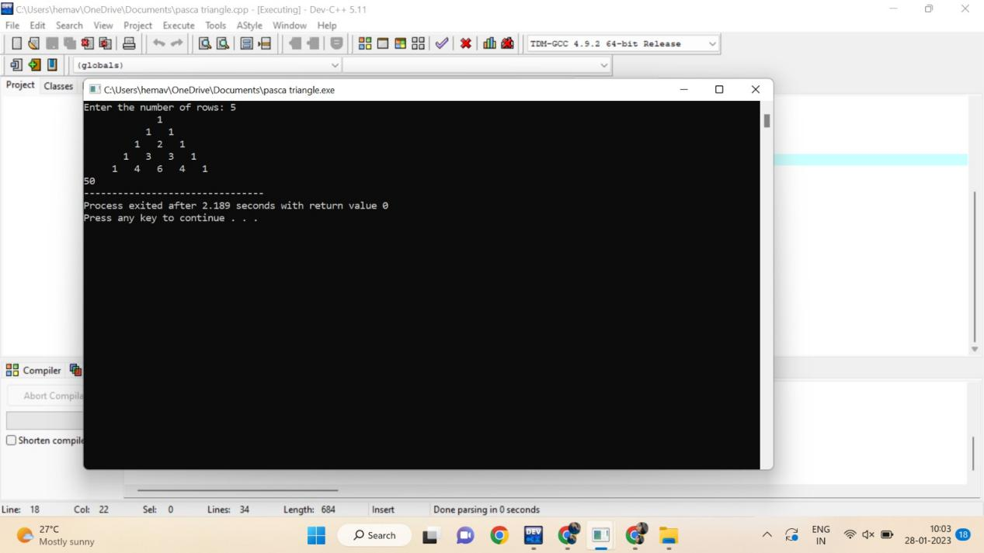

1. Given an array of integers nums which is sorted in ascending order, and an integer target, write a function to search target in nums. If target exists, then return its index. Otherwise, return -1.integer target. Write a program to search a number in a list using binary search and estimate time complexity

Program :

#include <stdio.h>

int main()

{

int i, low, high, mid, n, key, array[100];

int count=0;

printf("Enter number of elements");

scanf("%d",&n);

printf("Enter %d integers", n);

for(i = 0; i < n; i++)

scanf("%d",&array[i]);

printf("Enter value to find");

scanf("%d", &key);

low = 0;

count++;

high = n - 1;

count++;

mid = (low+high)/2;

count++;

while (low <= high) {

count++;

if(array[mid] < key)

low = mid + 1;

else if (array[mid] == key) {

count++;

printf("%d found at location %d ", key, mid+1);

break;

}

else

high = mid - 1;

mid = (low + high)/2;

count++;

}

if(low > high)

printf("Not found! %d isn't present in the list.n", key);

printf("time complexity : %d",count);

return 0;

}

OUTPUT:

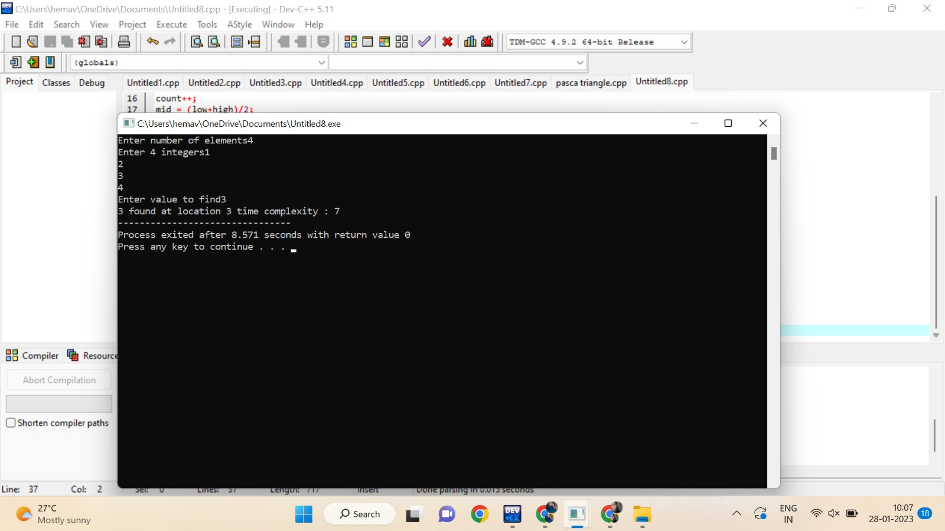

3. Write a program to check the given is Armstrong or not.

The k-digit number N is an Armstrong number if and only if the k-th power of

each digit sums to N.

Given a positive integer N, return true if and only if it is an Armstrong number.

Input : 153 Input : 419

Output : True Output : False

Also find the time complexity.

Program :

#include<stdio.h>

int main()

{

int n,r,sum=0,temp;

int count=0;

printf("enter the number=");

scanf("%d",&n);

temp=n;

while(n>0)

{

count++;

r=n%10;

count++;

sum=sum+(r*r*r);

count++;

n=n/10;

count++;

}

count++;

if(temp==sum)

printf("true ");

else

printf("false");

printf("%d",count);

return 0;

}

OUTPUT:

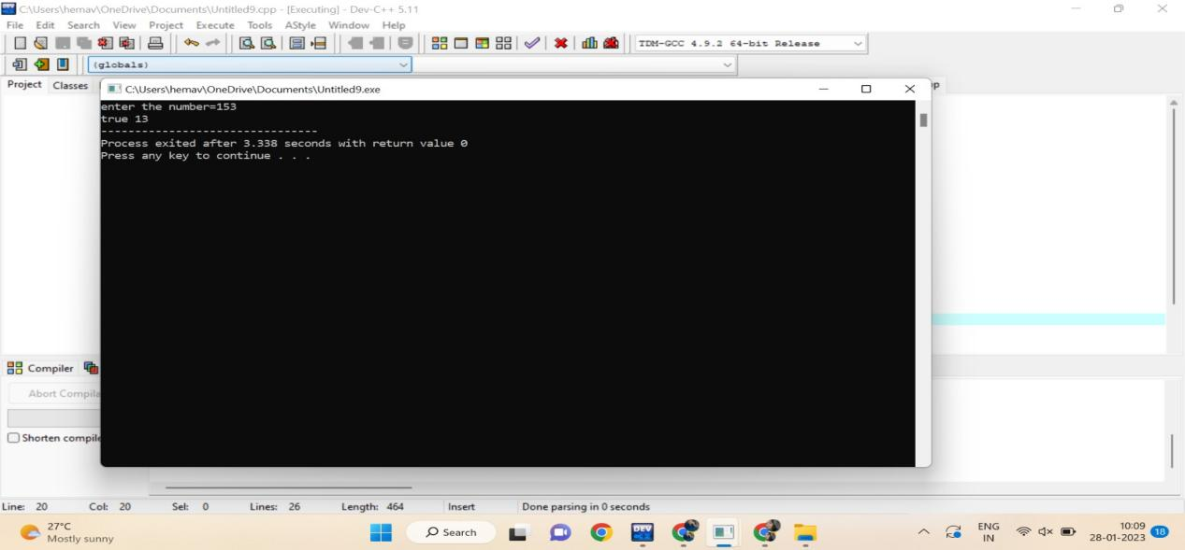

4.Write a C program to perform Strassen’s Matrix Multiplication for the 2*2 matrix elements.

And Estimate time complexity.

A Matrix= (3, 5,-4, 7) B Matrix – (9,-2, 4, 8)

Program :

#include<stdio.h>

int main()

{

int a[2][2], b[2][2], c[2][2], i, j;

int m1, m2, m3, m4 , m5, m6, m7;

int count=0;

printf("Enter the 4 elements of first matrix: ");

count++;

for(i = 0;i < 2; i++)

{

count++;

for(j = 0;j < 2; j++){

count++;

scanf("%d", &a[i][j]);

}

}

count++;

count++;

printf("Enter the 4 elements of second matrix: ");

for(i = 0; i < 2; i++){

count++;

for(j = 0;j < 2; j++){

count++;

scanf("%d", &b[i][j]);

}

}

count++;

printf("\nThe first matrix is\n");

for(i = 0; i < 2; i++){

count++;

printf("\n");

for(j = 0; j < 2; j++){

count++;

printf("%d\t", a[i][j]);

}

}

count++;

count++;

printf("\nThe second matrix is\n");

for(i = 0;i < 2; i++){

count++;

printf("\n");

for(j = 0;j < 2; j++){

count++;

printf("%d\t", b[i][j]);

}

}

count++;

count++;

m1= (a[0][0] + a[1][1]) * (b[0][0] + b[1][1]);

count++;

m2= (a[1][0] + a[1][1]) * b[0][0];

count++;

m3= a[0][0] * (b[0][1] - b[1][1]);

count++;

m4= a[1][1] * (b[1][0] - b[0][0]);

count++;

m5= (a[0][0] + a[0][1]) * b[1][1];

count++;

m6= (a[1][0] - a[0][0]) * (b[0][0]+b[0][1]);

count++;

m7= (a[0][1] - a[1][1]) * (b[1][0]+b[1][1]);

count++;

c[0][0] = m1 + m4- m5 + m7;

count++;

c[0][1] = m3 + m5;

count++;

c[1][0] = m2 + m4;

count++;

c[1][1] = m1 - m2 + m3 + m6;

count++;

printf("\nAfter multiplication using Strassen's algorithm \n");

for(i = 0; i < 2 ; i++){

count++;

printf("\n");

for(j = 0;j < 2; j++){

count++;

printf("%d\t", c[i][j]);

}

}

count++;

count++;

printf("%d",count);

return 0;

}

OUTPUT:

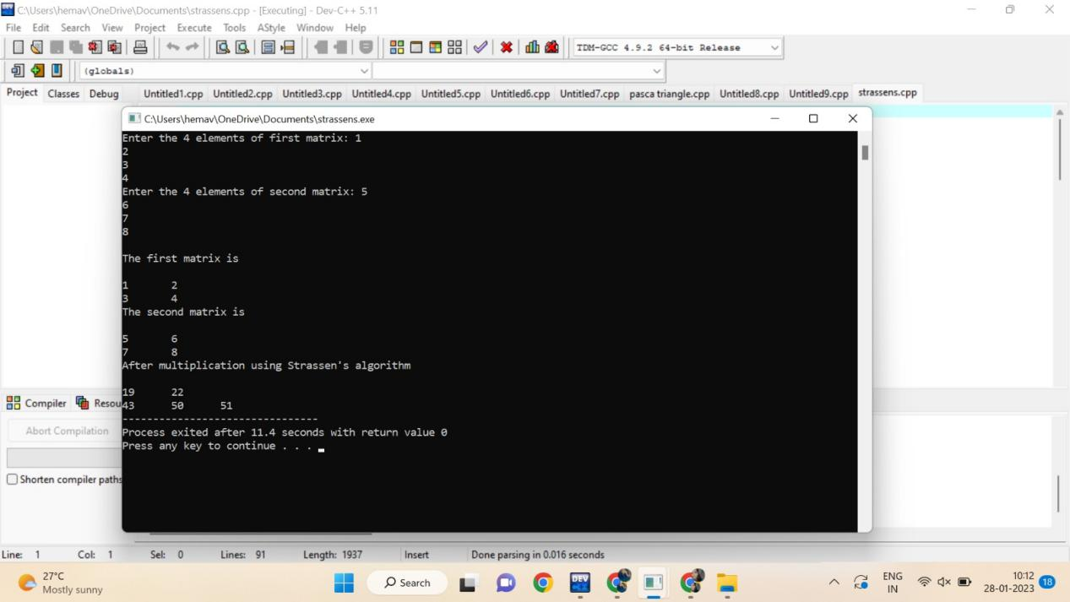

5. Compute the program to find the GCD of two numbers. And also find the time complexity.

Program:

#include <stdio.h>

int main()

{

int n1, n2, i, GCD_Num;

int count=0;

printf ( " Enter any two numbers: \n ");

scanf ( "%d %d", &n1, &n2);

for( i = 1; i <= n1 && i <= n2; ++i)

{

count++;

if (n1 % i ==0 && n2 % i == 0)

GCD_Num = i;

count++;

}

count++;

printf ("gcd of two numbers %d and %d is %d ", n1, n2, GCD_Num);

printf("time complexity :%d ",count);

return 0;

}

OUTPUT:

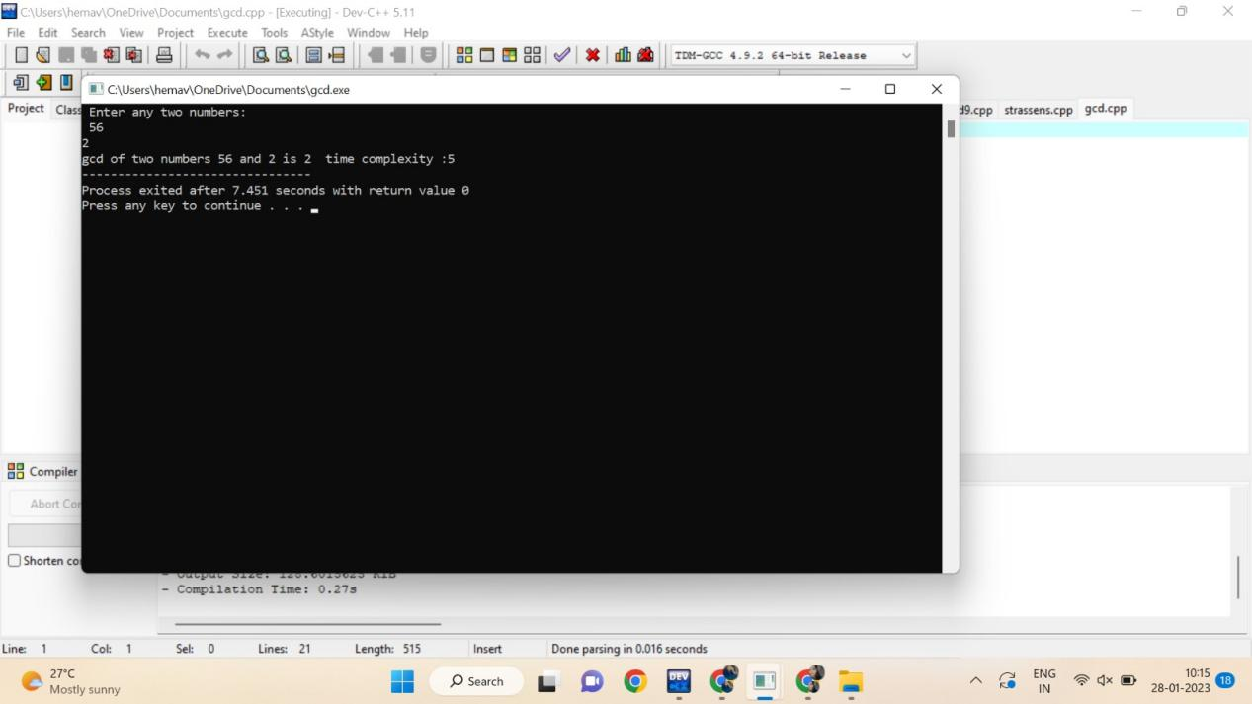

6. Compute Binomial coefficient for n=8, k=8 using dynamic programming

Using condition such as

I nCk =1 if k=0 or n=k

II nCk – (n-1)Ck-1 + (n-1)Ck for n>k>0

Program:

#include <stdio.h>

int count=0;

int bin_table(int val) {

for (int i = 0; i <= val; i++) {

count++;

printf("%2d", i);

int num = 1;

for (int j = 0; j <= i; j++) {

count++;

if (i != 0 && j != 0)

num = num * (i - j + 1) / j;

count++;

printf("%4d", num);

}

printf("\n");

count++;

}

}

int main() {

int value = 5;

bin_table(value);

printf("%d",count);

return 0;

}

OUTPUT:

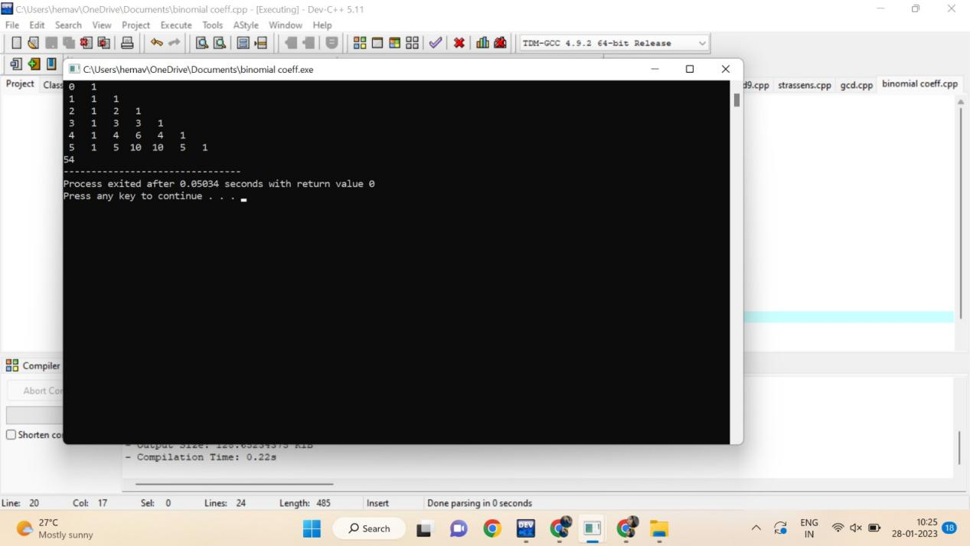

7 Write a program for to perform liner search and estimate time complexity. Compute the

amount of time for completion.

Input series

A = (56,89,7,13,75, 23, 8, 12) Key element 75

B= (89,45 -23,45,0, 44, 2) Key element 0

C= (45,67,56,A,34,-2,100) Key element 90

Program:

#include<stdio.h>

int main()

{

int array[100], search, c, n;

int count=0;

printf("Enter number of elements in array\n");

scanf("%d", &n);

printf("Enter %d integer(s)\n", n);

for (c = 0; c < n; c++)

{

count++;

scanf("%d", &array[c]);

}

count++;

printf("Enter a number to search\n");

scanf("%d", &search);

for (c = 0; c < n; c++)

{

count++;

if (array[c] == search)

{

printf("%d is present at location %d.\n", search, c+1);

break;

}

}

count++;

if (c == n)

printf("%d isn't present in the array.\n", search);

printf("%d",count);

return 0;

}

OUTPUT:

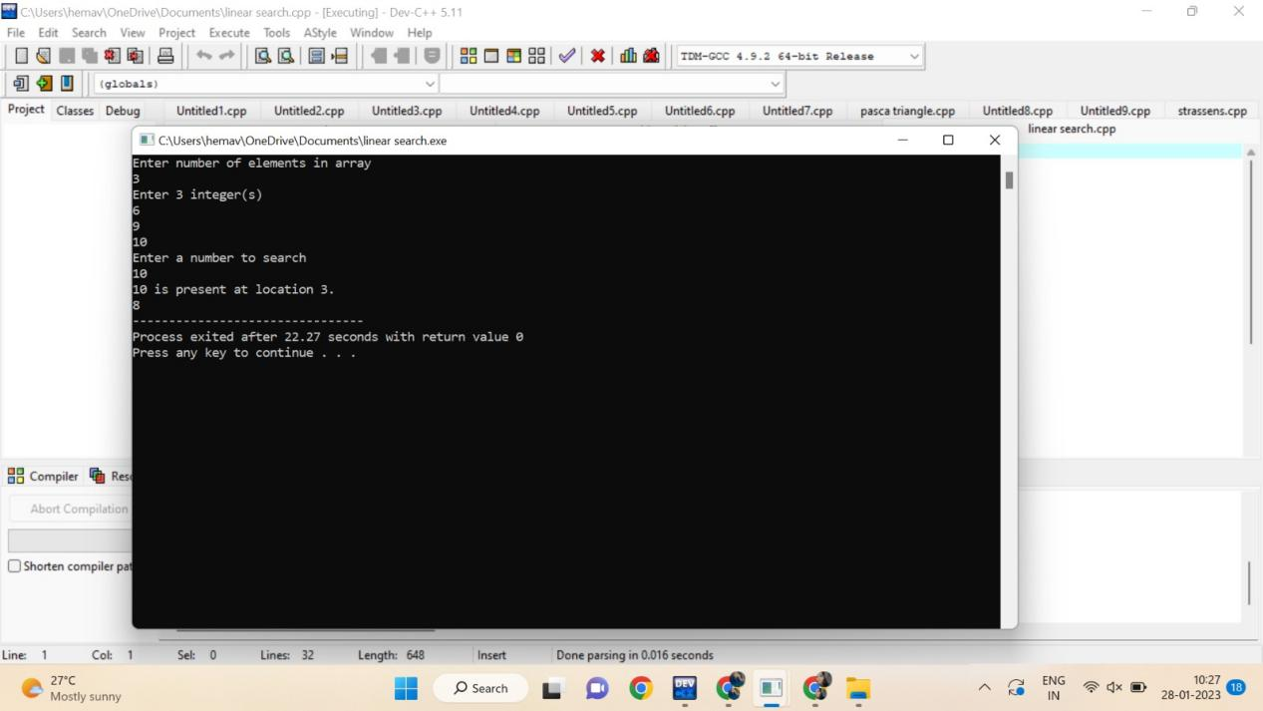

8. Write a program to find the largest element value in an array. Estimate the time complexity and no of

comparison for the given set of values.

Program:

#include <stdio.h>

int main() {

int n;

int count=0;

double arr[100];

printf("Enter the number of elements (1 to 100): ");

scanf("%d", &n);

count++;

for (int i = 0; i < n; ++i) {

count++;

printf("Enter number%d: ", i + 1);

scanf("%lf", &arr[i]);

}

for (int i = 1; i < n; ++i) {

count++;

if (arr[0] < arr[i]) {

arr[0] = arr[i];

}

count++;

}

printf("Largest element = %.2lf ", arr[0]);

printf("%d",count);

return 0;

}

OUTPUT:

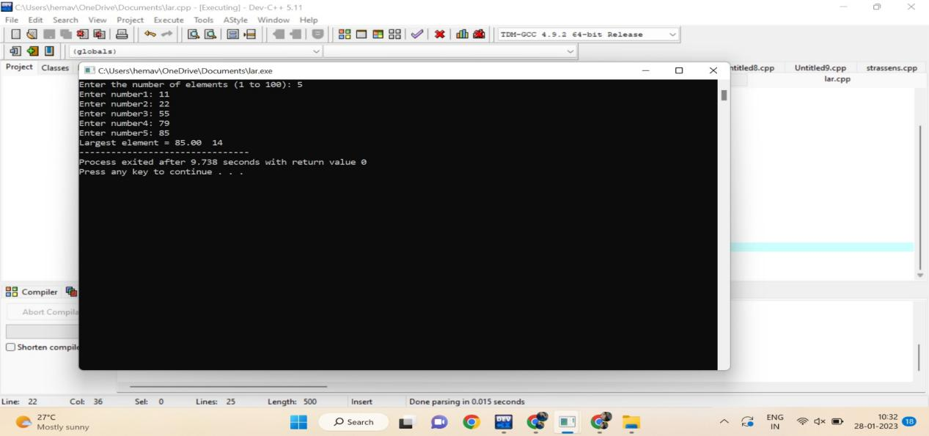

9. Write a program to find the factorial (fact)of a number and to estimate time complexity.

Condition such as i. n=0, return 1 otherwise fact (n-1) * n

Program :

#include <stdio.h>

int main() {

int n, i;

int count=0;

unsigned long long fact = 1;

printf("Enter an integer: ");

scanf("%d", &n);

count++;

if (n < 0)

printf("Error! Factorial of a negative number doesn't exist.");

else {

for (i = 1; i <= n; ++i) {

fact *= i;

count++;

}

printf("Factorial of %d = %llu ", n, fact);

printf(" time compexity : %d ",count);

}

return 0;

}

OUTPUT:

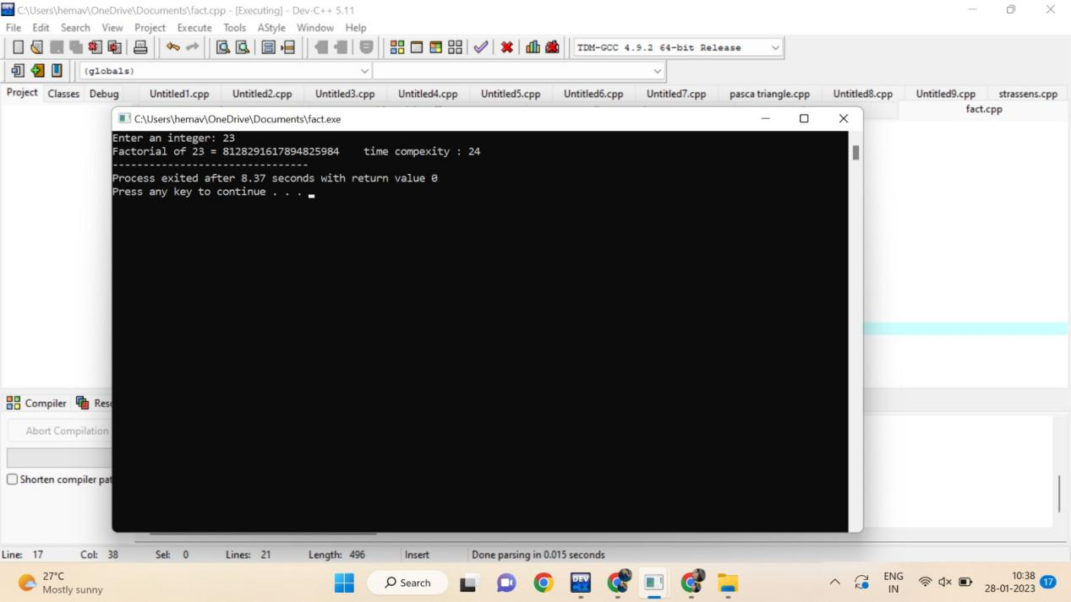

10. [Program to Find Even Sum of Fibonacci Series Till number N](https://www.geeksforgeeks.org/java-program-to-find-sum-of-fibonacci-series-numbers-of-first-n-even-indexes/)?(day 2)

Sample Input: n = 4

Sample Output: 33

(N = 4, So here the Fibonacci series will be produced from 0th term till 8th term: 0, 1, 1, 2, 3, 5, 8, 13, 21

Sum of numbers at even indexes = 0 + 1 + 3 + 8 + 21 = 33). Find the time complexity.

Program:

#include<stdio.h>

int count=0;

int main()

{

int n1=0,n2=1,n3,i,number;

count++;

printf("Enter the number of elements:");

scanf("%d",&number);

printf("\n%d %d",n1,n2);

for(i=2;i<number;++i)

{ count++;

n3=n1+n2;

count++;

printf(" %d",n3);

n1=n2;

count++;

n2=n3;

count++;

} count++;

printf("\ncount=%d",count);

return 0;

}

Output:

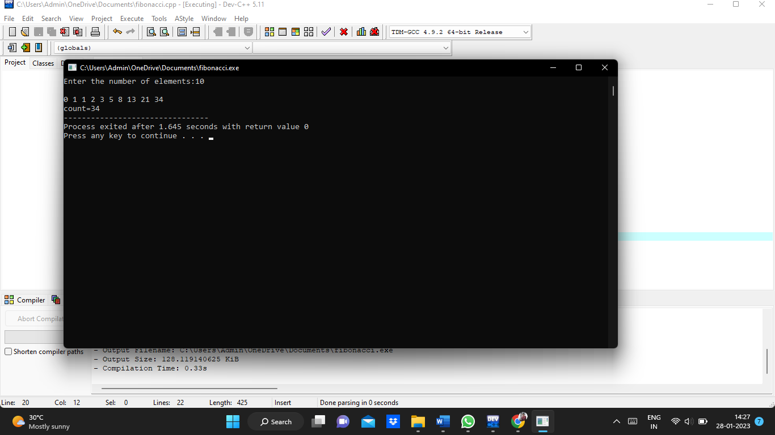

11. Write a program to print the first n perfect numbers. (Hint Perfect number means **a positive** integer that is equal to the sum of its proper divisors)

Sample Input:

N = 3

Sample Output:

First 3 perfect numbers are: 6 , 28 , 496

Test Cases:

1. N = 0
2. N = 5
3. N = -2
4. N = -5
5. N = 0.2

Find the time complexity

Program:

#include <stdio.h>

#include<math.h>

int count=0;

int isPerfect(long long int n) {

long long int dsum = 0;

long long int i;

count++;

for (i = 1; i <= sqrt(n); ++i) {

count++;

if (n % i == 0) {

count++;

if (i == n / i) {

dsum += i;

}

else {

dsum += i;

dsum += n / i;

count++;

}

count++;

}

count++;

}

count++;

dsum = dsum - n;

count++;

if (dsum == n) return 1;

else return 0;

}

int isPrime(long long int n) {

if (n == 1)

return 0;

for (int i = 2; i <= sqrt(n); ++i) {

count++;

if (n % i == 0)

return 0;

}

return 1;

count++;

}

int main() {

long long int n, i, temp;

printf("Enter n: ");

scanf("%d", &n);

count++;

i = 1;

while (n > 0) {

count++;

if (isPrime(i) == 1) {

temp = pow(2, i - 1) * (pow(2, i) - 1);

count++;

if (isPerfect(temp) == 1) {

printf("%d ", temp);

n = n - 1;

count++;

}

}

i = i + 1;

count++;

}

printf("\n");

printf("%d",count);

}

OUTPUT:

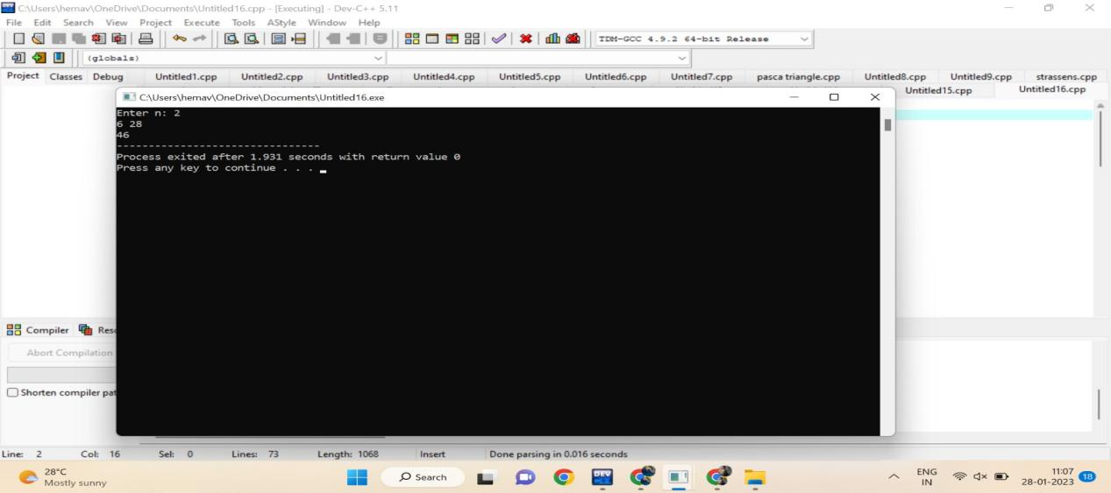

12. Write a program using choice to check

Case 1: Given string is palindrome or not

Case 2: Given number is palindrome or not

Sample Input:

Case = 1

String = MADAM

Sample Output:

Palindrome

Test cases:

1. MONEY
2. 5678765
3. MALAY12321ALAM
4. MALAYALAM
5. 1234.4321

Program:

#include <stdio.h>

#include <string.h>

int main(){

char string1[20];

int i, length;

int flag = 0;

int count=0;

printf("Enter a string:");

scanf("%s", string1);

length = strlen(string1);

count++;

for(i=0;i < length ;i++){

count++;

if(string1[i] != string1[length-i-1]){

flag = 1;

break;

count++;

}

count++;

}

count++;

if (flag) {

printf("%s is not a palindrome ", string1);

}

else {

printf("%s is a palindrome ", string1);

}

printf("time complexity : %d",count);

return 0;

}

OUTPUT:

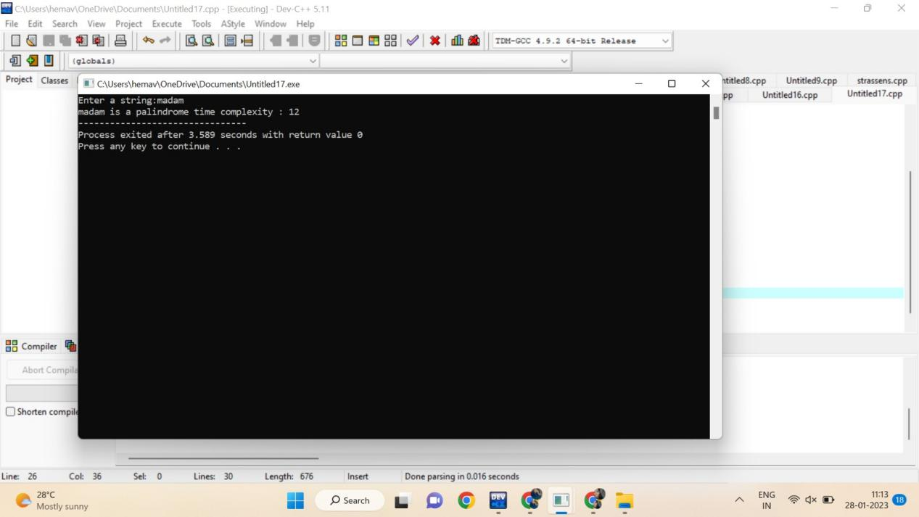

13. Write a program to perform Selection sort and estimate time Complexity

Estimate the time iteration for the following set of numbers.

1. (10,5, 80,-2,5,23, 45) B. (12, 3, 0, 34, -11, 34, 22, 8) C.( 3, 35, -56, 66, 77, ,-78, 82)

Program:

#include <stdio.h>

int main()

{

int a[100], n, i, j, position, swap;

int count=0;

printf("Enter number of elements:");

scanf("%d", &n);

printf("Enter Numbers:");

for (i = 0; i < n; i++)

scanf("%d", &a[i]);

for(i = 0; i < n - 1; i++)

{

position=i;

count++;

for(j = i + 1; j < n; j++)

{

if(a[position] > a[j])

position=j;

count++;

}

if(position != i)

{

swap=a[i];

a[i]=a[position];

a[position]=swap;

count++;

}

count++;

}

printf("\nSorted Array:");

for(i = 0; i < n; i++)

printf(" %d", a[i]);

printf(" time complexity : %d",count);

return 0;

}

OUTPUT:

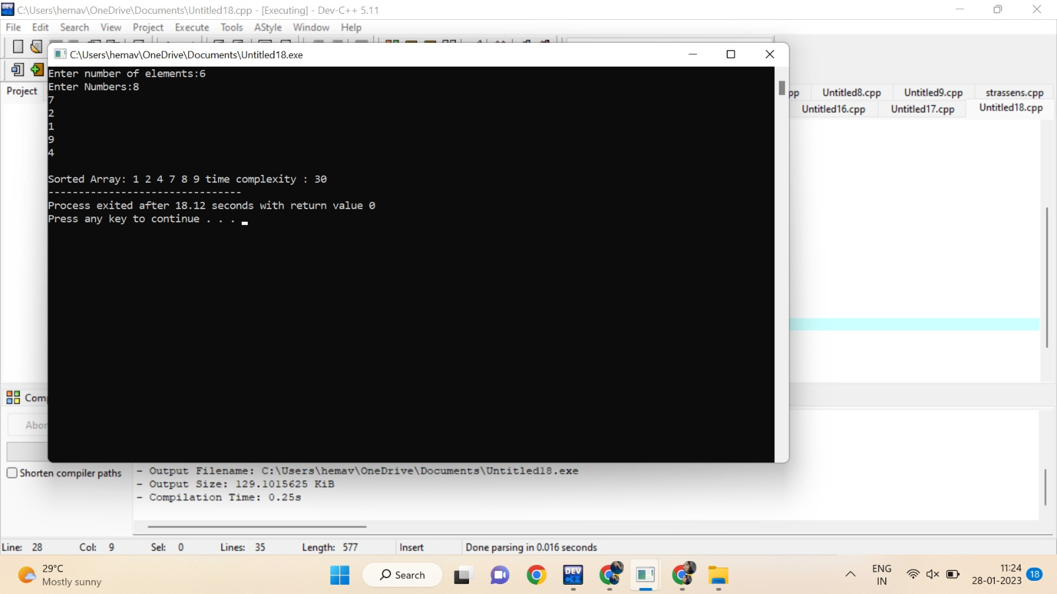

14. Write a program for the given pattern the given pattern If n=4

1

1 2

1 2 3

1 2 3 4

Program:

#include<stdio.h>

int main()

{

int rows, i, j;

int count=0;

printf("Enter the number of rows: ");

scanf("%d",&rows);

for(i = 1; i <= rows; i++)

{

for(j = rows; j > i; j--)

{

printf(" ");

count++;

}

for(j = 1; j <= i; j++)

{

printf("%d ",j);

count++;

}

printf("\n");

}

printf("%d",count);

return 0;

OUTPUT:

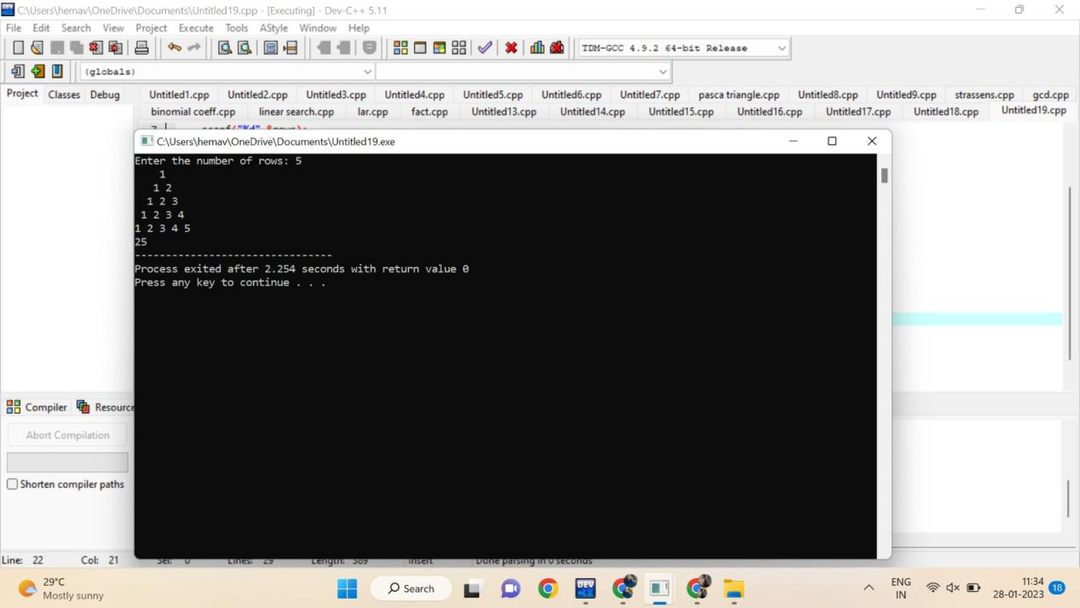

15. Write a program to return all the possible subsets for a given integer array. Return the

solution in any order.

Input nums= [1,2,3]

Output : [ [], [1], [2], [3], [1,2], [1,3], [2,3], [1,2,3]]

Program:

#include <stdio.h>

char string[50], n;

void subset(int, int, int);

int main()

{

int i, len;

printf("Enter the len of main set : ");

scanf("%d", &len);

printf("Enter the elements of main set : ");

scanf("%s", string);

n = len;

printf("The subsets are :\n");

for (i = 1;i <= n;i++)

subset(0, 0, i);

}

void subset(int start, int index, int num_sub)

{

int i, j;

if (index - start + 1 == num_sub)

{

if (num_sub == 1)

{

for (i = 0;i < n;i++)

printf("%c\n", string[i]);

}

else

{

for (j = index;j < n;j++)

{

for (i = start;i < index;i++)

printf("%c", string[i]);

printf("%c\n", string[j]);

}

if (start != n - num_sub)

subset(start + 1, start + 1, num_sub);

}

}

else

{

subset(start, index + 1, num_sub);

}

}

OUTPUT:

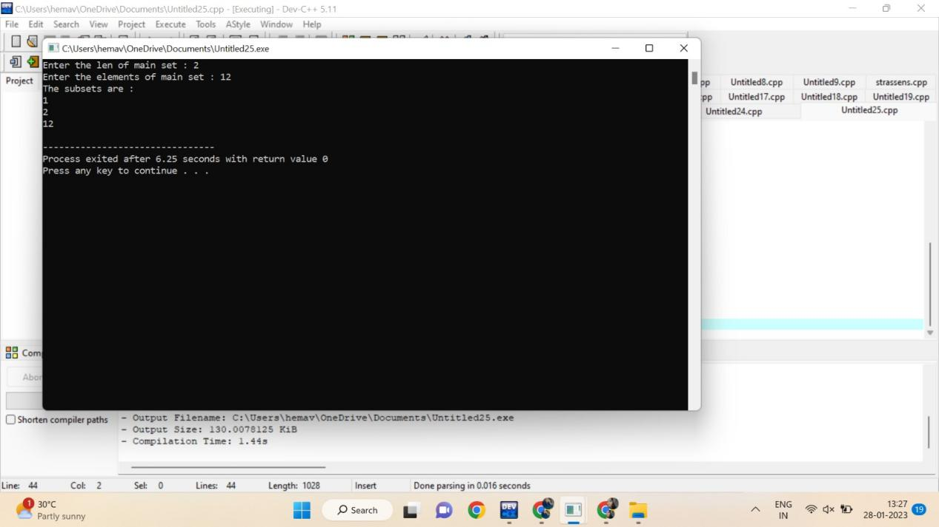

16. Write a program to check sub string is there in a string or not.

Input/Output

a.orginal string = "babad" b.Orginal string = "babad" c. Orginal string = "babad"

Sub string = "shahad" Sub string = "daa" Sub string = "aba"

Output = Not Found Output = Not Found Output = Found

Program:

#include<stdio.h>

int main()

{

char str[80], search[10];

int count1 = 0, count2 = 0, i, j, flag;

int count=0;

printf("Enter a string:");

gets(str);

printf("Enter search substring:");

gets(search);

while (str[count1] != '\0')

count1++;

while (search[count2] != '\0')

count2++;

for (i = 0; i <= count1 - count2; i++)

{

count++;

for (j = i; j < i + count2; j++)

{

count++;

flag = 1;

if (str[j] != search[j - i])

{

count++;

flag = 0;

break;

}

count++;

}

if (flag == 1)

break;

count++;

}

count++;

if (flag == 1)

printf("found");

else

printf("not found");

printf("%d",count);

}

OUTPUT:

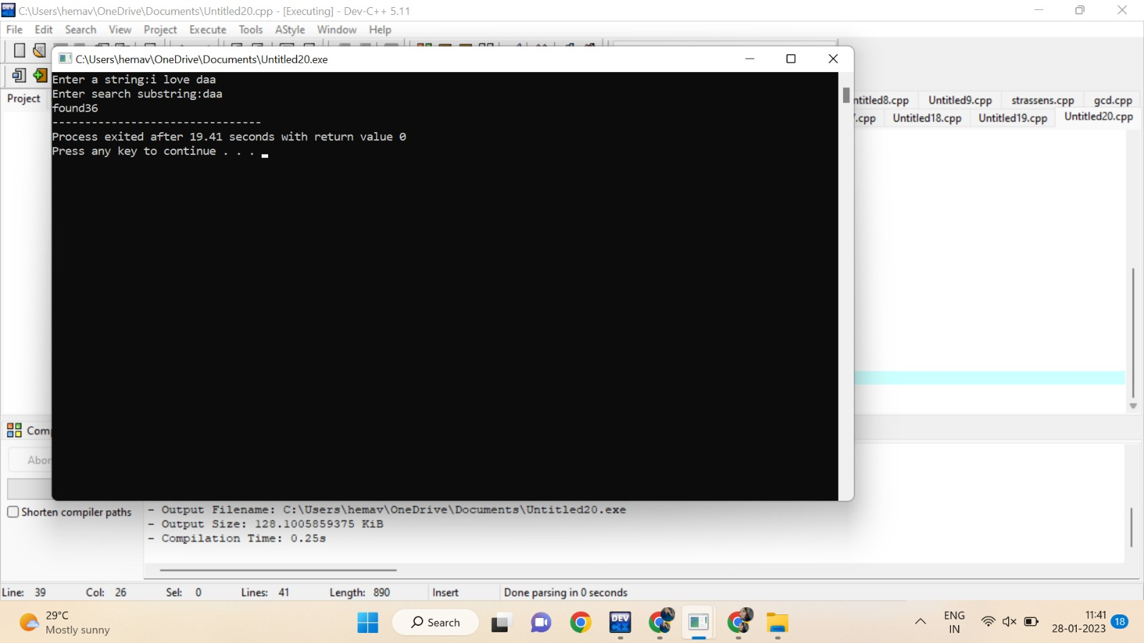

17.Write a program to perform sorting without using swapping and estimate time complexity.

Program:

#include <stdio.h>

int main()

{

int a[100], n, i, j, position, swap;

int count=0;

printf("Enter number of elements:");

scanf("%d", &n);

printf("Enter Numbers:");

for (i = 0; i < n; i++)

scanf("%d", &a[i]);

for(i = 0; i < n - 1; i++)

{

position=i;

count++;

for(j = i + 1; j < n; j++)

{

if(a[position] > a[j])

position=j;

count++;

}

if(position != i)

{

swap=a[i];

a[i]=a[position];

a[position]=swap;

count++;

}

count++;

}

printf("\nSorted Array:");

for(i = 0; i < n; i++)

printf(" %d", a[i]);

printf(" time complexity : %d",count);

return 0;

}

OUTPUT:



18.Write a program to print the reverse of a string. And estimate the time complexity

for the given inputs.

Test cases: output –

“ as\nr5Y” Y5rn|sa

“7yut02” 20tuy7

“EryEq qEyrE

Program:

#include<stdio.h>

Int main(){

char val[25];

printf("enter the value: ");

scanf("%s",&val);

int count=0,c=0;

while (val[count]!='\0'){

count++;

c++;

}c++;

for(int i=count-1;i>=0;i--){

c++;

printf("%c",val[i]);

}c++;

printf("\ncount: %d",c);

}

OUTPUT:

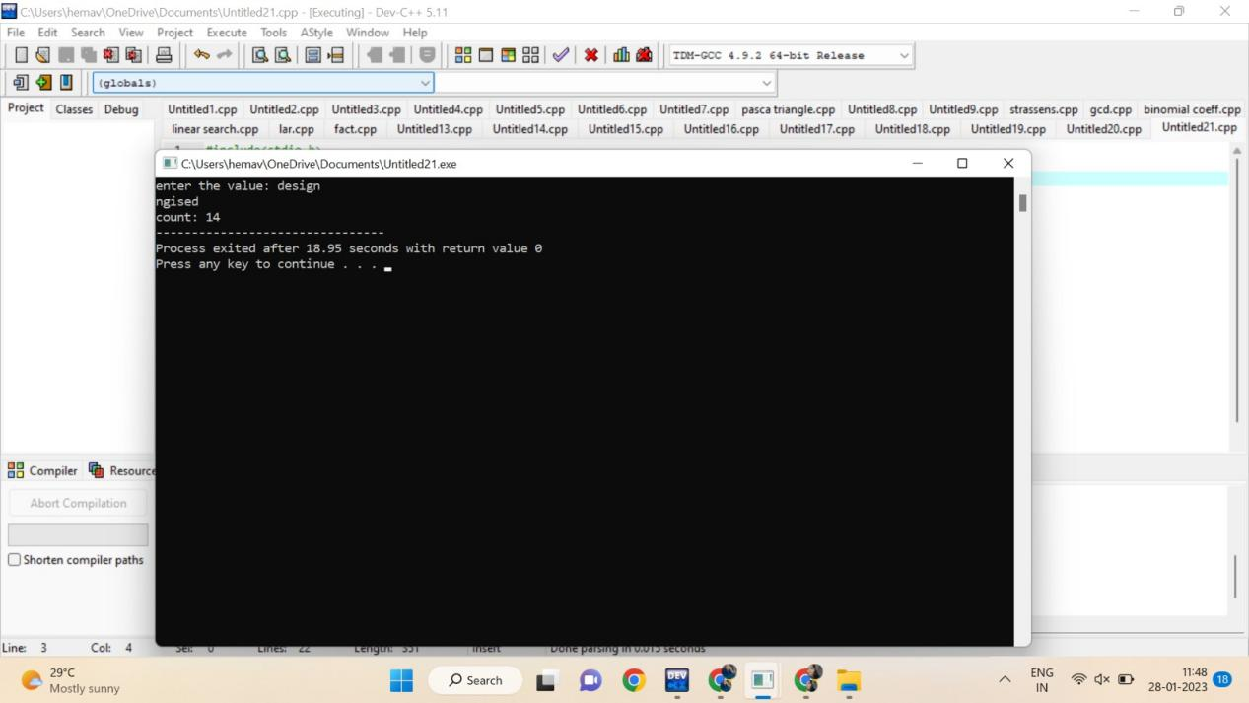

19.Write a program to perform Bubble sort and estimate time Complexity for n values.

Perform test cases for the following set of numbers.

1. .(10,5, 80,-2,5,23, 45) B. (12, 3, 0, 34, -11, 34, 22, 8) C.( 3, 35, -56, 66, 77, ,-78, 82)

Program:

#include<stdio.h>

void main(){

int ele,count=0;

printf("Enter tot element: ");

scanf("%d",&ele);

int arr[ele];

printf("Enter the elements: ");

for (int i = 0; i < ele; i++){

count++;

scanf("%d",&arr[i]);

}count++;

for (int i = 0; i < ele; i++)

{

count++;

for (int j =i+1; j < ele; j++)

{

count++;

if (arr[i]>arr[j])

{

count++;

int temp=arr[i];

count++;

arr[i]=arr[j];

count++;

arr[j]=temp;

count++;

}

}count++;

}count++;

printf("sorted array: ");

for (int i = 0; i < ele; i++)

{count++;

count++;

printf("%d ",arr[i]);

}count++;

printf("count: %d",count);

}

OUTPUT:

